

**Student Name: - Aziz Somani**

**### Mission 1**

**Mission 1 Answers: -**

* Determine and document the mail servers for starwars.com using NSLOOKUP.

**Answers: - “nslookup -type=MX starwars.com”**

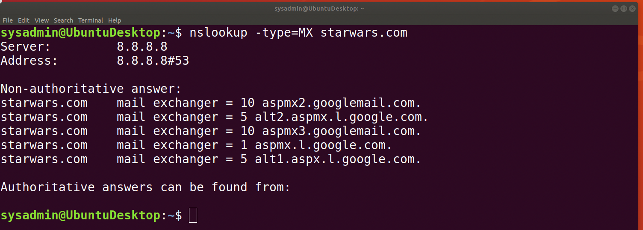

* Explain why the Resistance isn't receiving any emails.

**Answers: -** The new primary & secondary mail servers are not in the in the email exchange server record and all other URLs listed in the email exchange servers are incorrect that’s why the resistance is not receiving any e-mail.

* Document what a corrected DNS record should be.

**Answers: -** Below are the correct DNS records.

“Server: 8.8.8.8

Address: 8.8.8.8#53

Non-authoritative answer:

starwars.com mail exchanger = 1 aspmx.l.google.com.

starwars.com mail exchanger = 10 aspmx2.googlemail.com.

starwars.com mail exchanger = 10 aspmx3.googlemail.com.

starwars.com mail exchanger = 5 alt2.aspmx.l.google.com.

starwars.com mail exchanger = 5 alt1.aspx.l.google.com.

**starwars.com mail exchanger = 1 asltx.l.google.com**

**starwars.com mail exchanger = 2 asltx.2.google.com**

Authoritative answers can be found from:



**Student Name: - Aziz Somani**

**### Mission 2**

**Mission 2 Answers: -**

* Determine and document the `SPF` for `theforce.net` using NSLOOKUP.

**Answers: - “nslookup -type=txt theforce.net”**

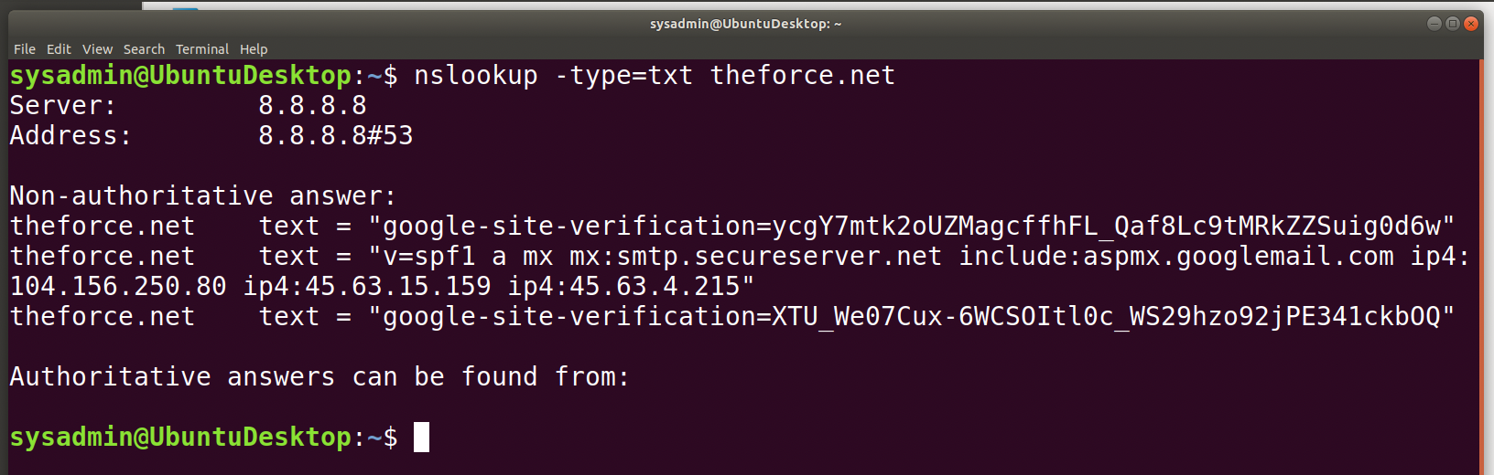

* Explain why the Force's emails are going to spam.

**Answers: -** The reason behind Force's emails are going to spam due to `theforce.net` changed the IP address of their mail server to `45.23.176.21` and the new IP address '45.23.176.21' is not listed in the SPF record that's why it's indicating that it is not coming from theforce.net and its coming as spam.

* Document what a corrected DNS record should be.

**Answers: -** The corrected DNS record should have the new IP address `45.23.176.21`.

Below is the example: -

Server: 8.8.8.8

Address: 8.8.8.8#53

Non-authoritative answer:

theforce.net text = "google-site-verification=ycgY7mtk2oUZMagcffhFL_Qaf8Lc9tMRkZZSuig0d6w"

theforce.net text = "v=spf1 a mx mx:smtp.secureserver.net include:aspmx.googlemail.com ip4:104.156.250.80 ip4:45.63.15.159 ip4:45.63.4.215 **ip4:45.23.176.21**"

theforce.net text = "google-site-verification=XTU_We07Cux-6WCSOItl0c_WS29hzo92jPE341ckbOQ"

Authoritative answers can be found from:



**Student Name: - Aziz Somani**

**### Mission 3**

**Mission 3 Answers: -**

* Document how a CNAME should look by viewing the CNAME of `www.theforce.net` using NSLOOKUP.

**Answers: - “nslookup -type=cname www.theforce.net”**

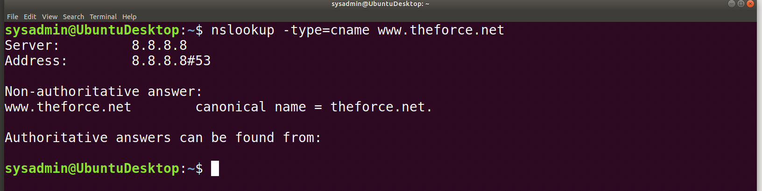

Also I did **“nslookup -type=cname resistance.theforce.net”** and it is showing server can't find resistance.theforce.net and there is no cname record for it.

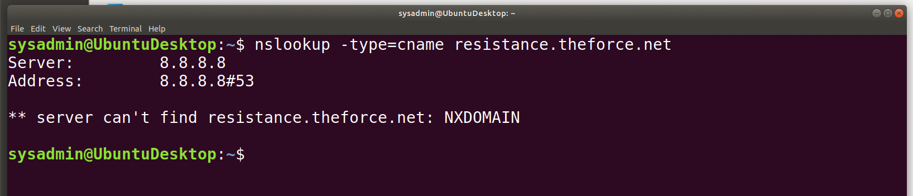

* Explain why the sub page of `resistance.theforce.net` isn't redirecting to `theforce.net`.

**Answers: -** By using NSLOOKUP it's shows that the canonical name `theforce.net` currently listed for www.theforce.net, this should be listed for resistance.theforce.net there for it should be automatically redirected from their subpage of `resistance.theforce.net` to `theforce.net`.

* Document what a corrected DNS record should be.

**Answers: -** Corrected DNS record should be resistance.theforce.net instead of www.theforce.net.

Below is the corrected record: -

Server: 8.8.8.8

Address: 8.8.8.8#53

Non-authoritative answer:

resistance.theforce.net canonical name = theforce.net.

Authoritative answers can be found from:



**Student Name: - Aziz Somani**

**### Mission 4**

**Mission 4 Answers: -**

* Confirm the DNS records for `princessleia.site`.

**Answers: -** Below is the DNS records command for `princessleia.site` to show the backup DNS servers.

**“nslookup -type=ns princessleia.site”**

After the command run, I was not able to find `ns2.galaxybackup.com` in the DNS record for `princessleia.site`.

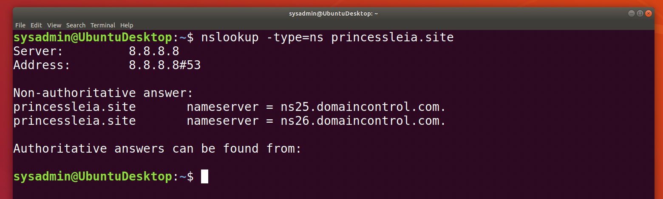

* Document how you would fix the DNS record to prevent this issue from happening again.

**Answers: -** To fix this DNS record, the backup DNS server ns2.galaxybackup.com should be added to nameserver so the backup server can be accessed.

Below is the corrected DNS records for `princessleia.site` : -

Server: 8.8.8.8

Address: 8.8.8.8#53

Non-authoritative answer:

princessleia.site nameserver = ns25.domaincontrol.com.

princessleia.site nameserver = ns26.domaincontrol.com.

**princessleia.site nameserver = ns2.galaxybackup.com.**

Authoritative answers can be found from:



**Student Name: - Aziz Somani**

**### Mission 5**

* View the [Galaxy Network Map](resources/Galaxy_Network_map.png) and determine the `OSPF` shortest path from `Batuu` to `Jedha`.
* Confirm your path doesn't include `Planet N` in its route.
* Document this shortest path so it can be used by the Resistance to develop a static route to improve the traffic.

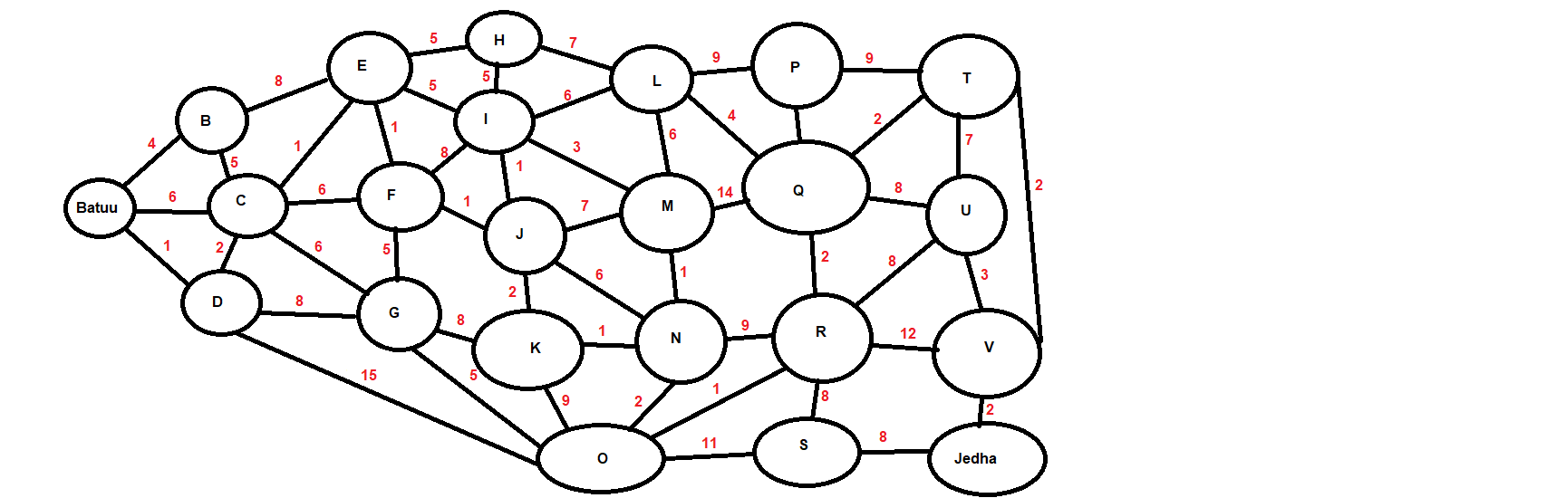

**Mission 5 Answers: -**

Below is the shortest path from `Batuu` to `Jedha` so it will be helpful and can be used by the resistance to develop a static route and improve the traffic.

**Shortest Path** - **(Batuu – D – C – E – F – J – I – L – Q – T – V - Jedha)** – Total travel count is 23 and this is the shortest path and it's not passing through planet N.



**Student Name: - Aziz Somani**

**### Mission 6**

**Mission 6 Answers: -**

* Figure out the Dark Side's secret wireless key by using Aircrack-ng.
* Hint: This is a more challenging encrypted wireless traffic using WPA.
* In order to decrypt, you will need to use a wordlist (-w) such as `rockyou.txt`.

**Answers: -** I have moved rockyou.txt file in to resources folder and run aircrack-ng to find secret wireless key and SSID from Darkside.pcap file.

Below is command to found secret wireless key & SSID.

**“aircrack-ng -w rockyou.txt Darkside.pcap”**

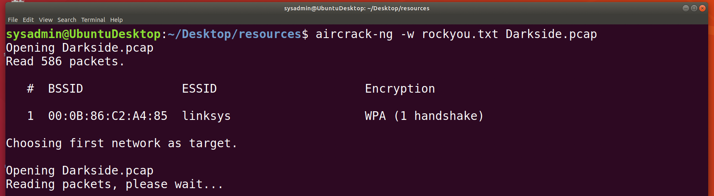

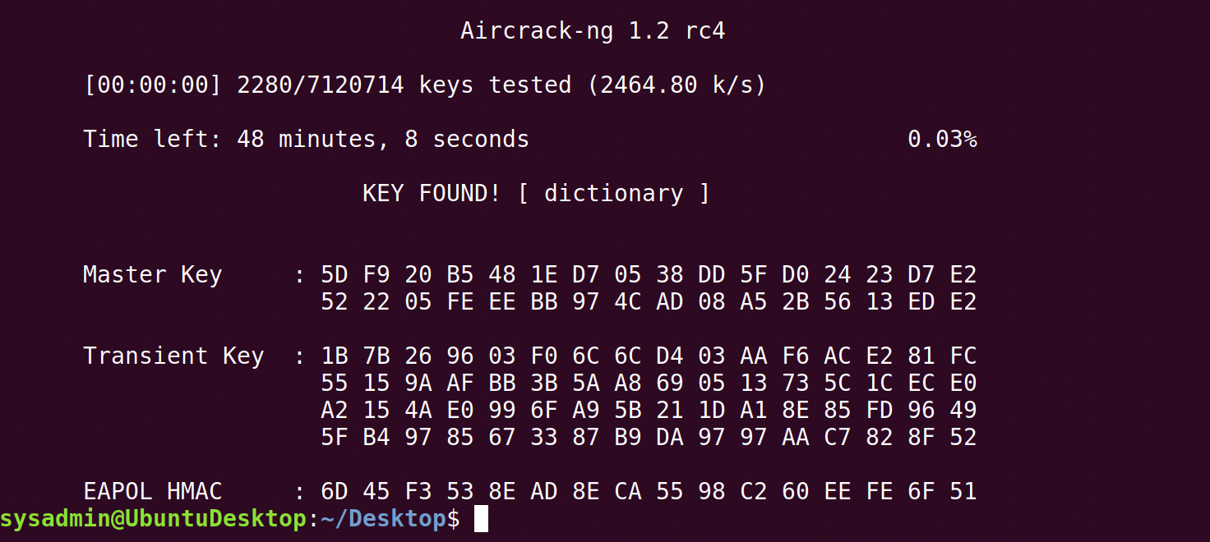

* Use the Dark Side's key to decrypt the wireless traffic in Wireshark.
  + Hint: The format for they key to decrypt wireless is `<Wireless_key>:<SSID>`.

**Answers: -** I add key in to Wireshark IEEE 802.11 (KEY-TYPE was "wpa-pwd" and KEY was ‘**dictionary’** but the format for the key to decrypt was `<Wireless_key>:<SSID>` so I have add key like this "**dictionary:linksys**") and decrypted the traffic.

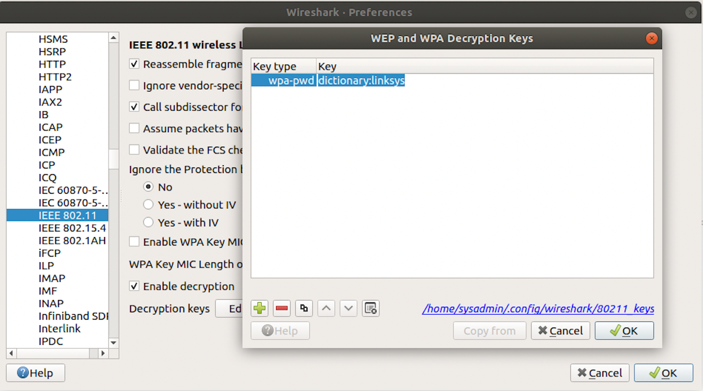

* Once you have decrypted the traffic, figure out the following Dark Side information:
* Host IP Addresses and MAC Addresses by looking at the decrypted `ARP` traffic.

**Answers: -** I Filtered the Darkside.pcap by **arp** to figure out the dark side information and I found IP address and Mac Address.

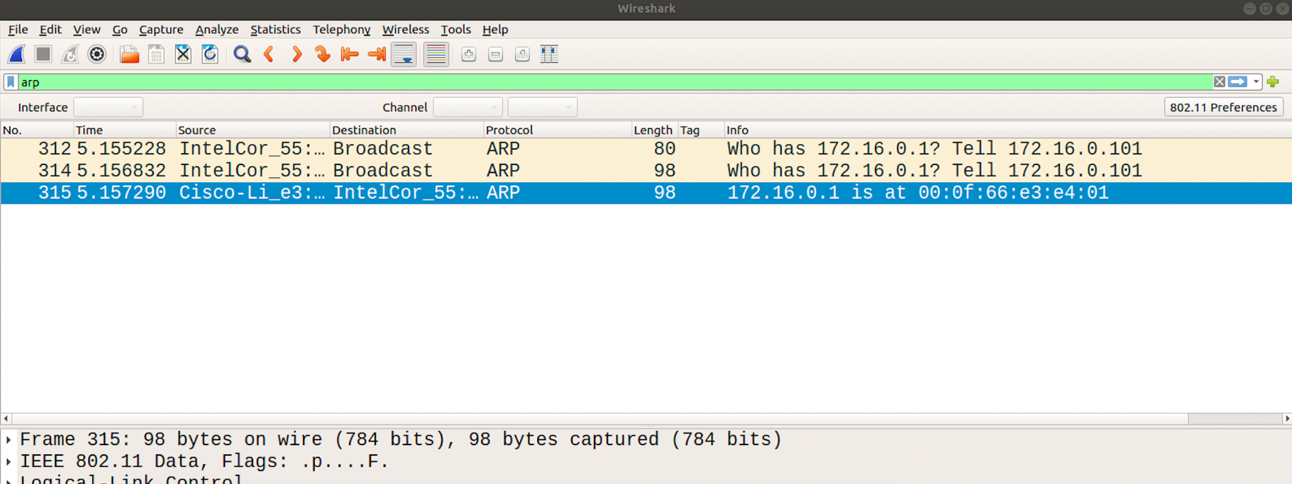



**Student Name: - Aziz Somani**

* Document these IP and MAC Addresses, as the resistance will use these IP addresses to launch a retaliatory attack.

**Answers: -** Below are IP address and MAC address.

Sender MAC address: Cisco-Li_e3:e4:01 (00:0f:66:e3:e4:01)

Sender IP address: 172.16.0.1 (172.16.0.1)

Target MAC address: IntelCor_55:98:ef (00:13:ce:55:98:ef)

Target IP address: 172.16.0.101 (172.16.0.101)

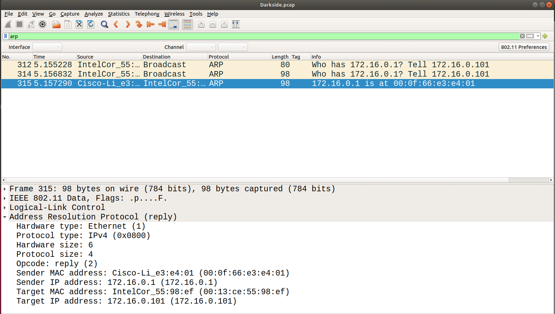



**Student Name: - Aziz Somani**

**### Mission 7**

* View the DNS record from Mission #4.
* The Resistance provided you with a hidden message in the `TXT` record, with several steps to follow.
* Follow the steps from the `TXT` record.
* **Note**: A backup option is provided in the TXT record (as a website) in case the main telnet site is unavailable
* Take a screen shot of the results.

**Mission 6 Answers: -**

I did nslookup for princessleia.site from mission #4 and below is command.

**"nslookup -type=txt princessleia.site"**

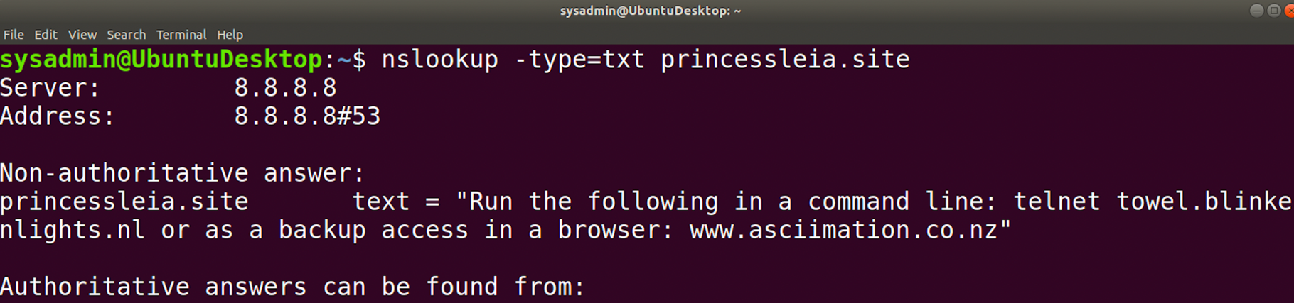

I have tried running telnet towel.blinkenlights.nl but it didn't work and I was unable to connect so I visited the www.asciimation.co.nz website. Here is screen shot of the results.

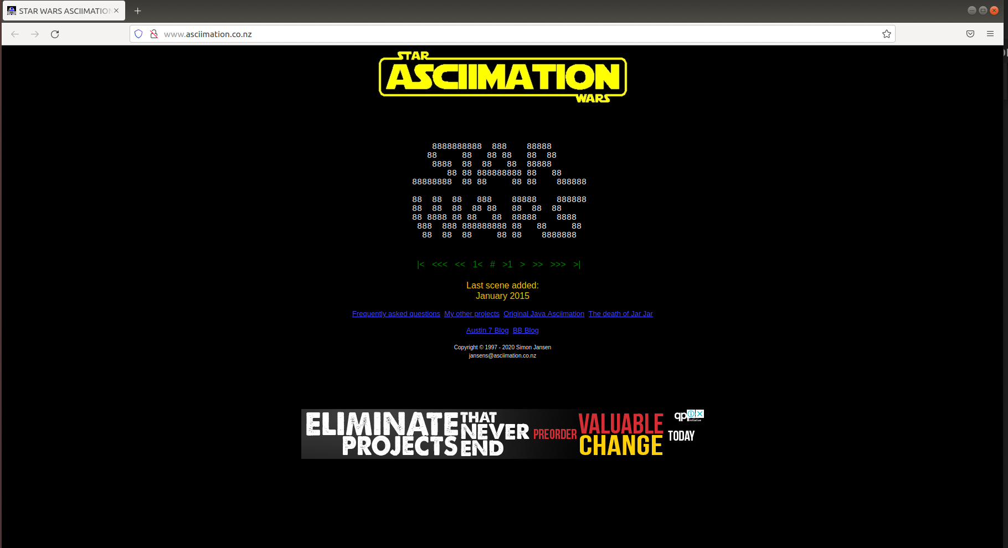

**Thank you,**

Aziz Somani